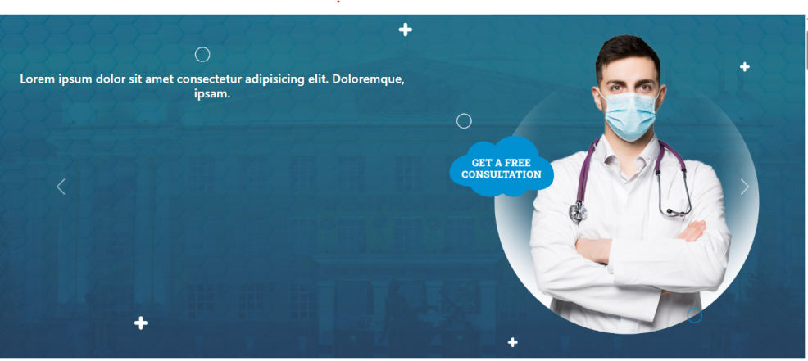 

Career image

Size: 1061\*387

Home images

Size: 1343\*573.56

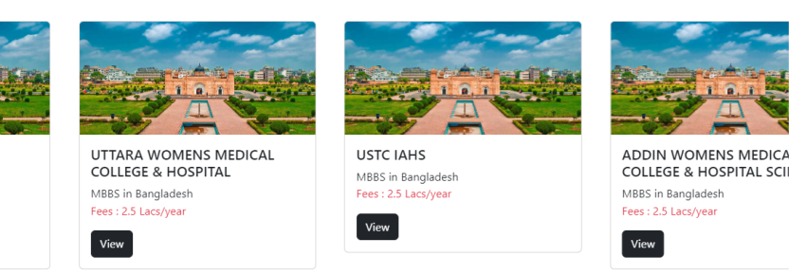

container

Size: 315\*180

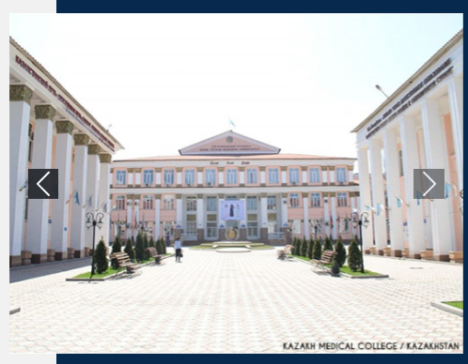

Visitor section

Size: 488.88\*367.83

Country section

Size: 259.19\*152.67





review section

Size: 206.33\*381.69

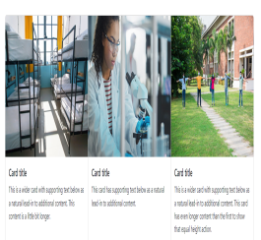

container

Size: 369.67\*249.77